AFLAC IS AVAILABLE THRU WALLER!

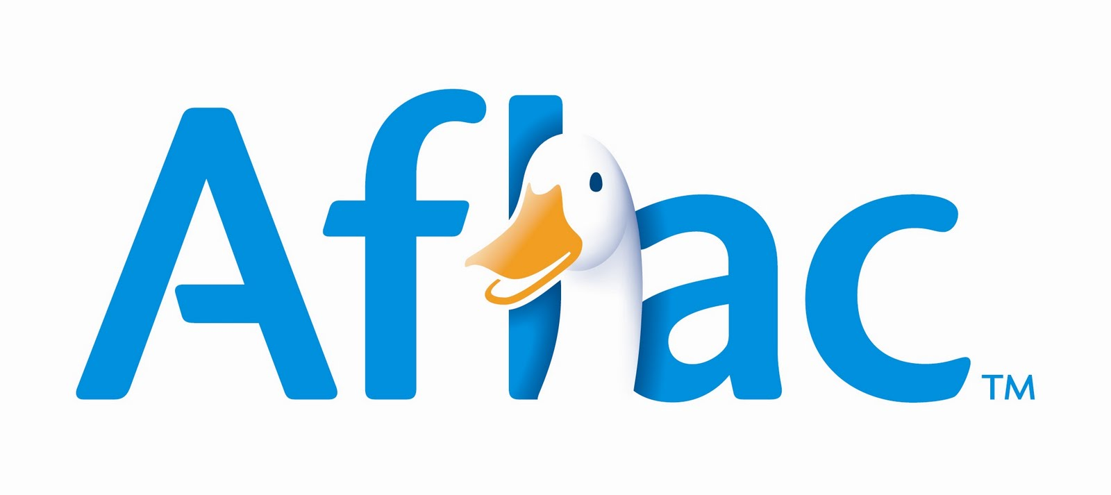

Waller Truck offers the following insurance services through Aflac:

ACCIDENT
Helps cover the expenses associated with accidental injury. Benefits are
determined by each state but may include:
- Accident Emergency Treatment
- Accident Initial Hospitalization
- Accidental – Death and Dismemberment
- Wellness Benefit

CANCER / SPECIFIED DISEASE
Pays a First-Occurrence Benefit when a diagnosis of internal cancer is made.
Benefits are determined by each state but may include:
- Hospital Confinement
- Reconstructive Surgery
- Radiation and Chemotherapy
- National Cancer Institute (NCI) Evaluation/Consultation
- Wellness

HOSPITAL CONFINEMENT INDEMNITY
Helps cover the expenses associated with hospital stays. Benefits are
determined by state and plan level selected, but may include:
- Daily Hospital Confinement
- Rehabilitation Unit

SHORT-TERM DISABILITY / INCOME REPLACEMENT
Helps cover your paycheck should you be off work Dr. recommended. Benefits are
determined by state and coverage level selected.

See your Agent for details!

AFLAC WORKSHEET
FOR
WALLER EMPLOYEES
